· Introduction

o Goals and Objective

Most companies have transportation services for employees. The main objective of this software is to minimize the cost of transportation for the employees. For example: The employees living in the same area would be able to share a vehicle to work. The factors that have been used for the minimization of cost using this software are: the type of vehicle used, the number of vehicles needed and the distance between the company and the area where a set of employees needs to go.

The distributed Ground Transportation System provides the ability for companies to offer transportation to employees using one of three transportation types of vehicles. They are motorcycle, cab, or a bus. Each type has a different capacity with a standard rate per distance. The distance is based on zones. A zone is a location identifier that is assigned to the physical addresses (address of company as well as address of employees). The price is based on the distance i.e. zone to zone and type of vehicle. The main purpose of this design document is to demonstrate the methods we have used to design the software and also the major objective of the software. It also provides a brief outline of the features of our distributed system to companies who would like to implement it with their current logistics. It aims at describing how the problem is being solved, and the different features that will be required in order to have an acceptable solution to this problem. The scope of this document also includes the design of the important features and a loose description as to how our program will function to meet these requirements. To recap, I have also included the use-case diagram of the application below:

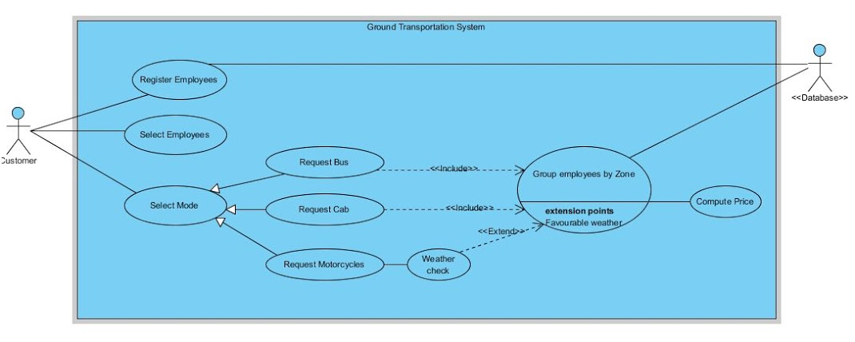

There are three major functionalities that the software does:

· **Register Employees**- This is to add new employees within the system. This would include details of the employee like the address and what kind of transportation he would prefer. This information would help us to divide employees based on zones and then assigning the type of vehicle based on the number of people travelling to one area.

· **Select Employees**- Once the employees have been registered, we divide the employees based on zones. This functionality helps us to group the employees based on their location.

· **Select Mode**- Here, when a particular employee selects a type of transport, a database search is done as to how many employees living in the same area have asked for transportation. Once the data has been fetched, the total cost of travel has been computed based on they type of vehicle he asks for. In certain cases when the employee looks for motorcycle as his preferred mode of transportation, it also has the option of checking whether the weather is suitable to ride a motorcycle. If it is, he is assigned one.

o Project Overview

This product is a conglomeration of other products out on the market today. There are no comprehensive human logistic solutions available in our market. Our distributed system takes the major features of publicly available transportation APIs and combines them with privately contracted transportation options.

Our program is supposed to act as an interface to every mode of ground transportation available to get an employee to work. The different distributed objects that would be used are:

· **Company**: The Company is a client in the system that has employees that need transportation. When the client starts the company generates/registers the number of employees with their address details (automatic random generation including the location of that company). This data is stored in the database. The company has an option to select the type of vehicle and also number of employees that need transportation. The system then contacts the TMS object and a cost is returned. Since this is the client in our distributed system, it can have multiple instances.

· **Transportation Management System (TMS)**: The TMS has communication with three service providers that provide their own service. For example a cab service provides transportation using cabs only. Now, on receiving the request from the Client/Company, based on client’s choice of vehicle type TMS forwards the request to the service provider. TMS has contact with a public API to access weather information. If it is raining it will not forward the request to the motorcycle service provider since it cannot operate in the rain.

· **Databases**: This object is responsible for generating/registering employees into the database for each client. It will also be used as the skeleton for interaction with the database.

· **CabServices**: This object will calculate how many cabs are needed to transport from one zone to another and the total cost. It has access to the database and can calculate cost of transport for all employees in each zone for all zones. A vehicle travels only to one zone.

· **MotorcycleServices**: This object will calculate how many motorcycles are needed to transport from one zone to another and the total cost. This type of vehicle cannot operate in the rain. It has access to the database and can calculate cost of transport for all employees in each zone for all zones. A vehicle travels only to one zone.

· **BusServices**: This object will calculate how many buses are needed to transport from one zone to another and the total cost. It has access to the database and can calculate cost of transport for all employees in each zone for all zones. A vehicle travels only to one zone.

The Ground Transportation System does utilize a public API. The system will use a public API from a weather service to determine if the vehicle can operate in current weather conditions.

o Software Context

The reason behind the development of this software can be better described with the help of this example.

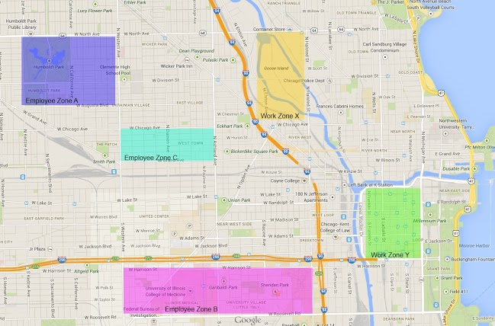

The picture above is a single instance of how the Ground transportation system can be used. Here there are two work zones: Work zone X and work zone Y. With the employee information and which work zone they are requesting the particular vehicle from, the users are divided into particular Employee zones. Thus the company incurs the minimum cost of travel.